Evernote Tutorial Focusing on the Web-Clippper

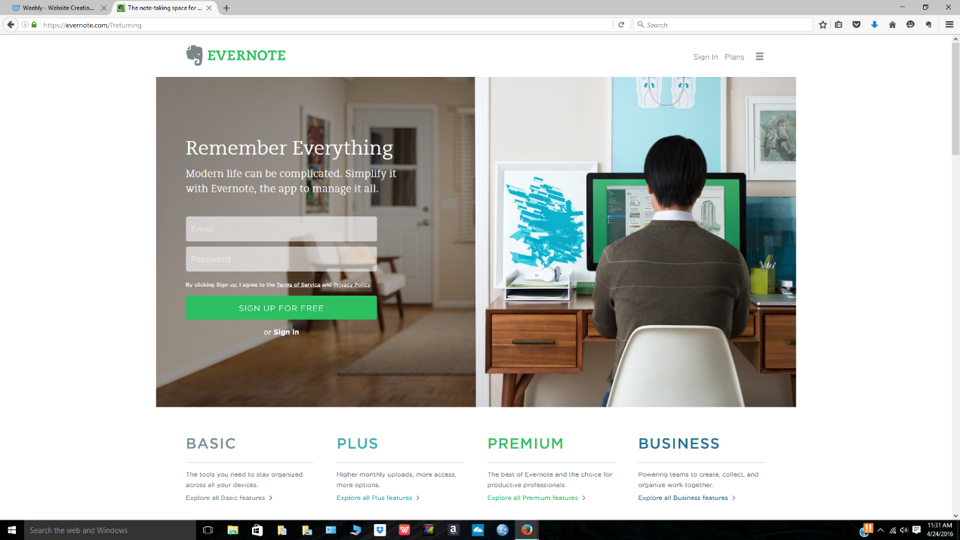
To get started, open your web browser and type in Evernote’s URL into the URL box (www.evernote.com). When you hit enter, you should be looking at the screen below.

If you see this page, you are in the right place. If you do not see this page, try opening up google and searching for Evernote. It will be the first item on the list. To sign up for Evernote for free, you are going to click on the green button that says “Sign up for free.” It should bring you to this page below, where you will provide an email and a password for your Evernote account.
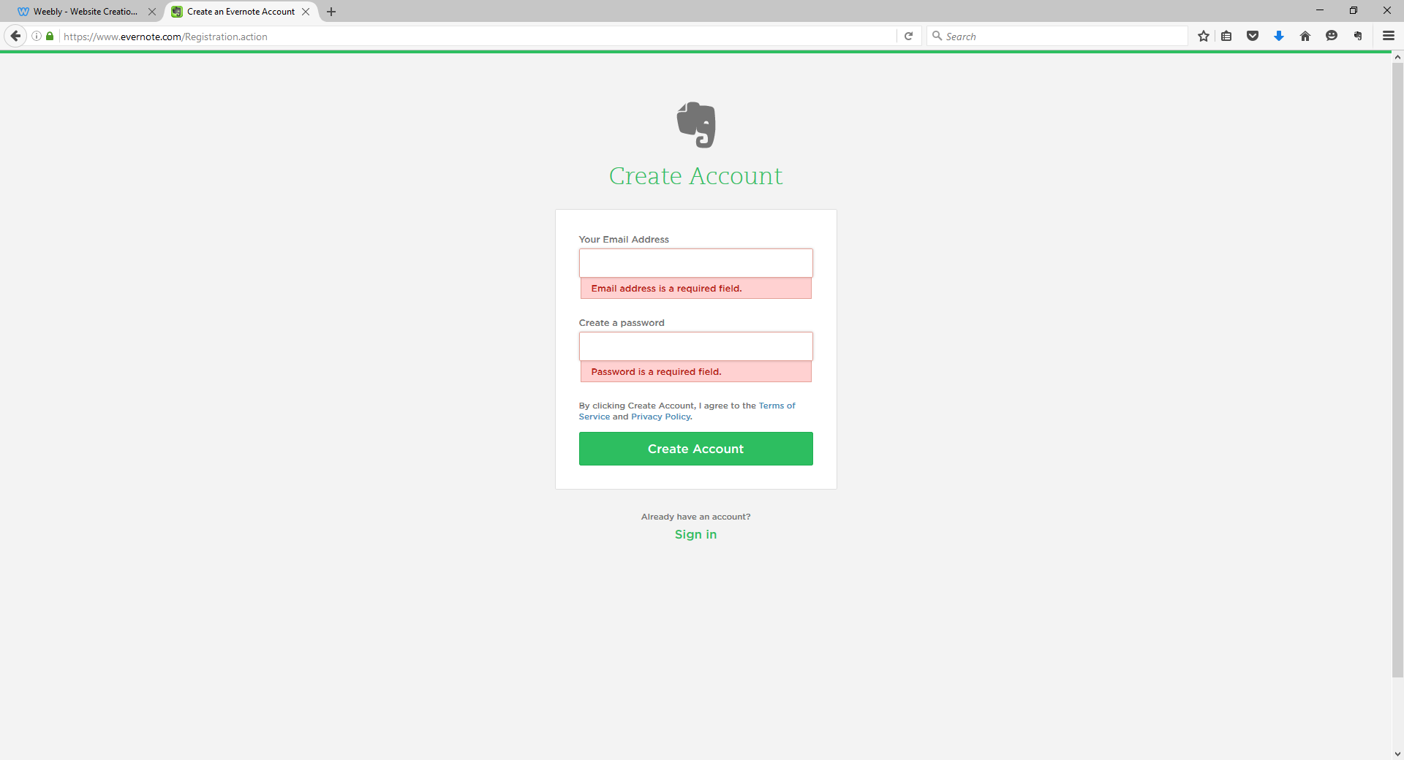
Now, it is time to sign in. After you sign in, it will bring you to your home page. Your home page will look like the picture below.
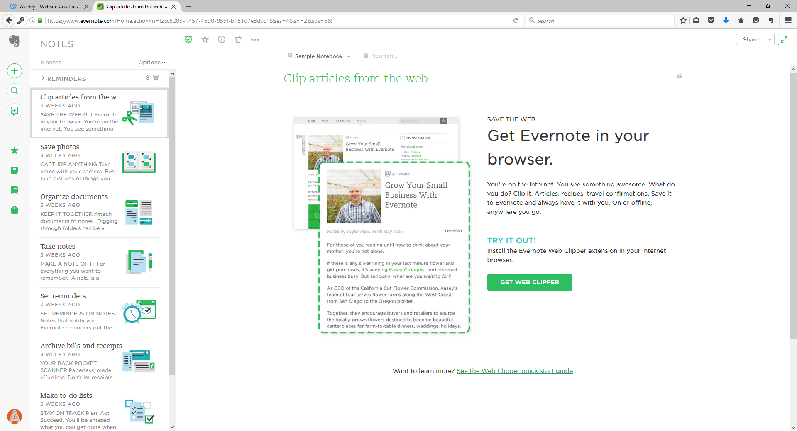
Now, Evernote has instructions for literally everything, so there is no need to go through this step-by-step. However, I will be showing you how to do a few major things on Evernote. For example, the first item on your to-do list now that you’ve signed up is to install Evernote’s web-clipper. As you can see from the picture above, the web-clipper is on your home page. Simply click the green button that says “get web clipper.” When you click on the green button, it will pull up a brand new page on a new tab. The page will look like the one below.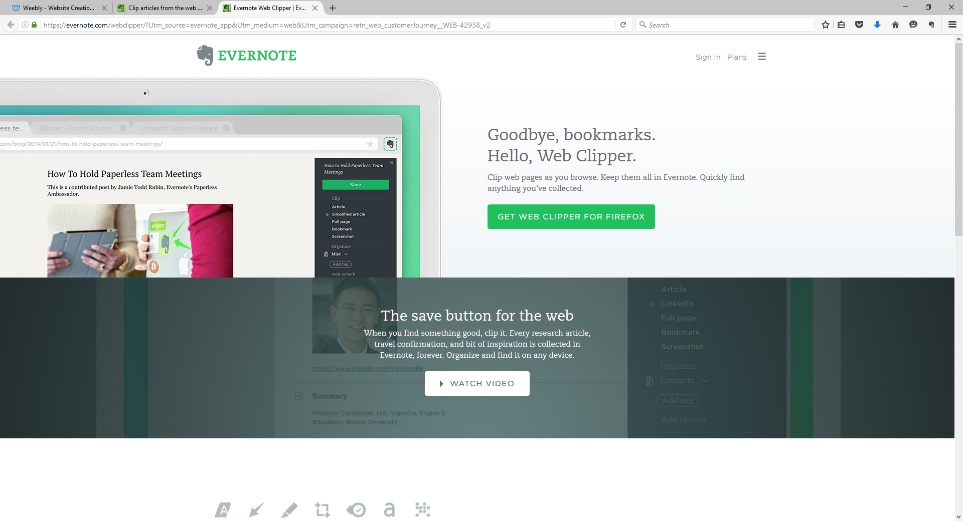
Click the green button that says “Get Web Clipper for Firefox (or whatever web browser you are currently using. If you are indeed using Firefox, it will bring you to the page below.
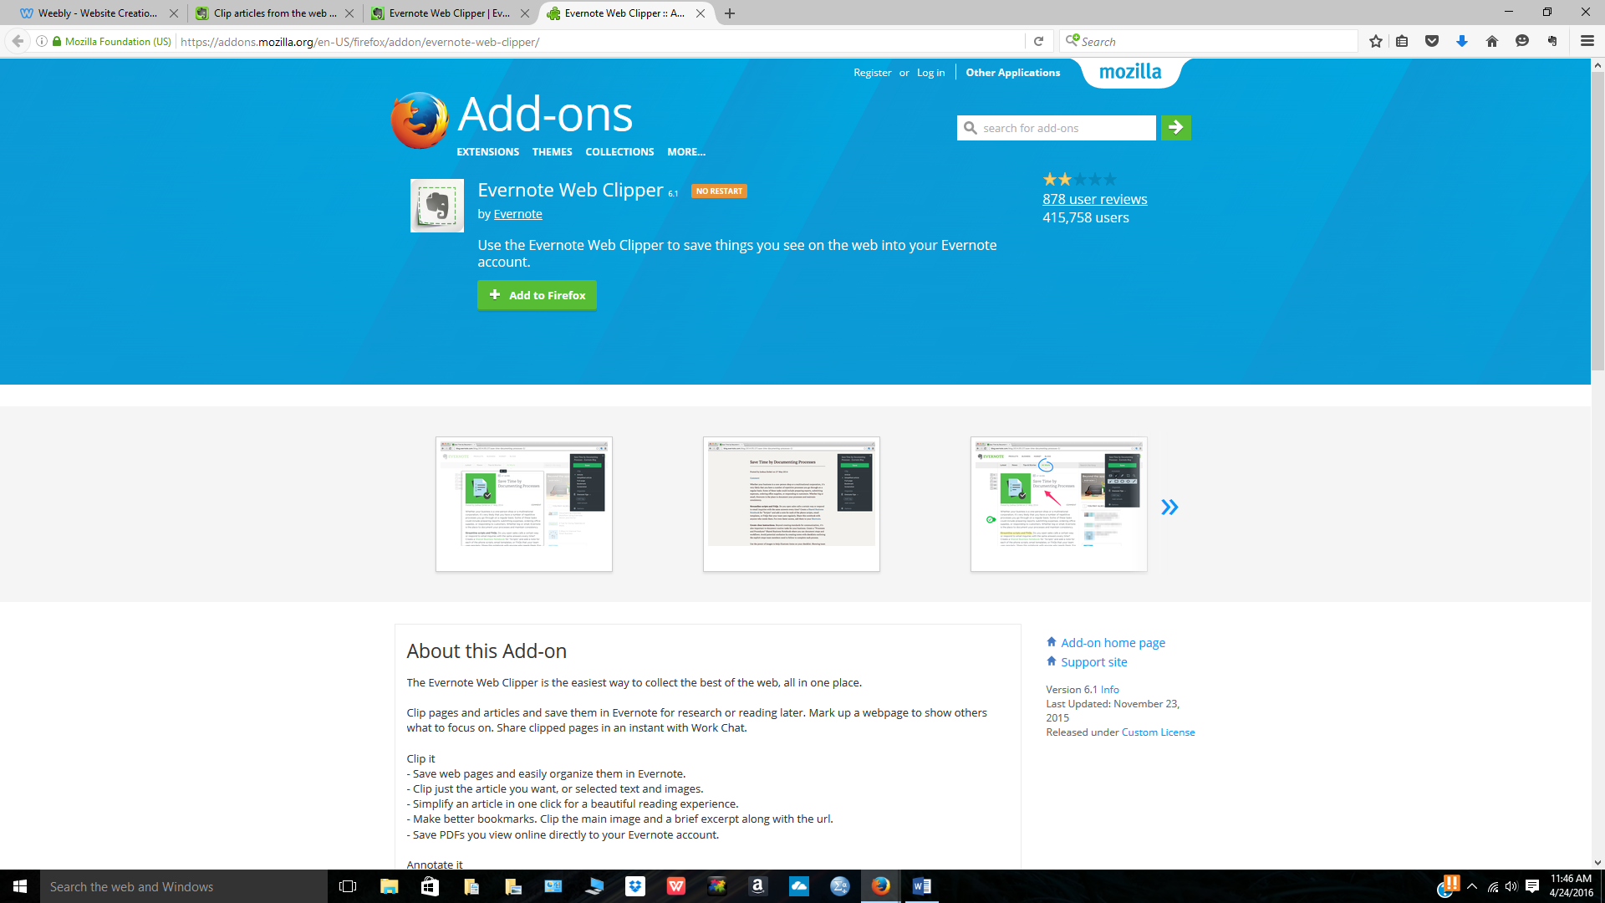
Then, simply click “Add to Firefox”, and hit install when the pop-up comes up. The web-clipper will show up as an elephant icon in the far right-hand corner of your browser. If you see the elephant, the web-clipper is installed!
Now, how do you clip items from the web? It’s easy. I’ll show you. I have gone to google and looked up Henry VIII as an example. The website is www.biology.com. The website looks like this.

Now to clip the entire page, simply click on your elephant and select full page. See the picture below.
Now hit save and it will automatically be saved to one of your notebooks on Evernote. Shown below is your Notebook Tab on Evernote. Click on this tab to see what you have clipped from the web.
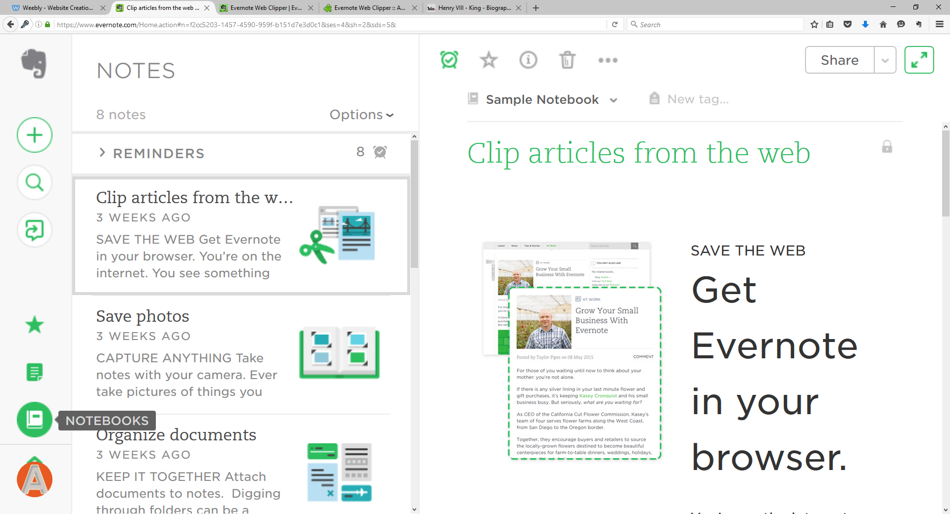

Here it is! The web clipping will show up in a notebook, where you can move it, tag it, or add it to your favorites. See the image below.
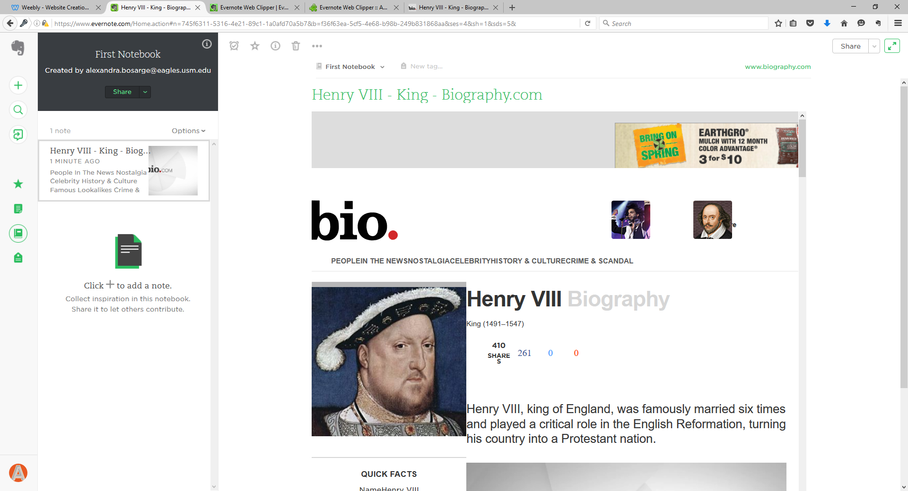

Now, you’re an expert on the Web-Clipping Feature on Evernote!

